**CSE3011 NETWORK PROGRAMMING**

**LAB EXPERIMENT 8**

NAME – B PRATYUSH

REGISTRATION NUMBER – 19BCN7114

LAB SLOT – L11+L12

FACULTY – PROF. MUNEESWARI

**Experiment Description: Sample Programs on URL and Ip**

**CODE 1**

**Get IP address using Socket Programming**

**Server Code**

**GetIPAddress.java**

import java.net.*;

import java.io.*;

import java.util.*;

public class GetIPAddress{

public static void main(String[] args )throws IOException {

BufferedReader input = new BufferedReader(new InputStreamReader(System.in));

System.out.print("Enter the host name: ");

String hostname = input.readLine();

ServerSocket s=new ServerSocket(8080);

try {

InetAddress inetadd = InetAddress.getByName(hostname);

System.out.println("IP address is: " + inetadd.getHostAddress());

Socket soc=s.accept();

DataOutputStream out=new DataOutputStream(soc.getOutputStream());

out.writeBytes("Server Date: " + (new Date()).toString() + "\n");

BufferedReader in=new BufferedReader(new InputStreamReader(soc.getInputStream() ));

System.out.println(in.readLine());

out.close();

soc.close();

}

catch(UnknownHostException e ){

System.out.println("Could not find IP address for: " + hostname);

}

}

}

**Client Side**

**GetIPClient.java**

import java.net.*;

import java.io.*;

public class GetIPClient {

public static void main(String[] args) throws IOException {

// TODO Auto-generated method stub

Socket soc=new Socket("localhost",8080);

DataInputStream din=new DataInputStream(soc.getInputStream());

BufferedReader br=new BufferedReader(new InputStreamReader(System.in));

String str2="";

while((str2=br.readLine())!=null)

{

str2=din.readUTF();

System.out.println(""+str2);

}

soc.close();

}

}

**Output:**

**Server End:**

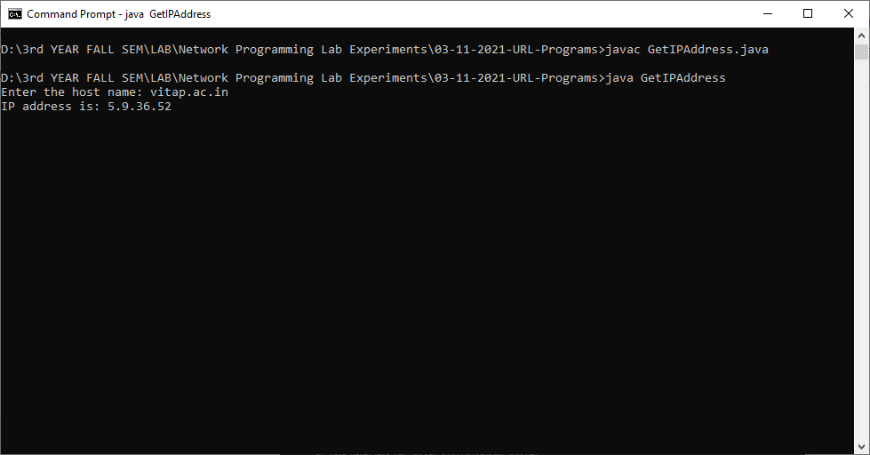

**Client End:**

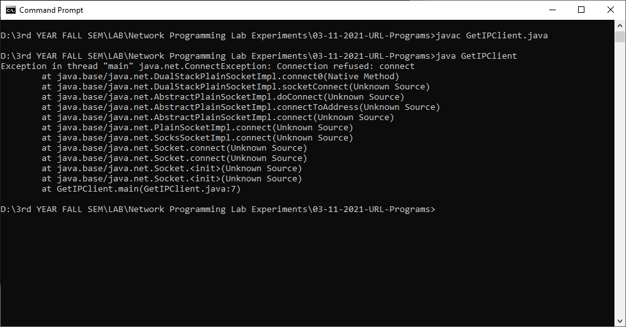

**Code 2**

**URLInfo.java**

**package** lab8;

**import** java.net.*;

**import** java.io.*;

**import** java.util.Date;

**import** java.util.*;

**public** **class** URLinfo {

**public** **static** **void** main(String[] args) **throws** Exception {

// **TODO** Auto-generated method stub

**int** c;

System.***out***.println("Enter No of Urls");

Scanner sin=**new** Scanner(System.***in***);

**int** n=sin.nextInt();

**for**(**int** j=0;j<n;j++) {

System.***out***.println("Enter URL "+(j+1)+" : ");

String u =sin.next();

URL url = **new** URL(u);

URLConnection con = url.openConnection();

System.***out***.println("URL Info");

System.***out***.println("Date: " + **new** Date(con.getDate()));

System.***out***.println("Content-Type: " + con.getContentType());

System.***out***.println("Expires: " + con.getExpiration());

System.***out***.println("Last-Modified: " + **new** Date(con.getLastModified()));

**int** len = con.getContentLength();

System.***out***.println("Content-Length: " + len);

System.***out***.println("Content Encoding: "+con.getContentEncoding());

System.***out***.println("Read Timeout: "+con.getReadTimeout());

System.***out***.println("Header Field: "+con.getHeaderField(20));

**if** (len > 0)

{

System.***out***.println("------------!!Content!!--------");

InputStream input = con.getInputStream();

**int** i = len;

**while**(((c = input.read()) != -1) && (i > 0))

{

System.***out***.print((**char**) c);

}

input.close();

}

**else**

{

System.***out***.println("No Content Available");

}

}

sin.close();

}

}

**Output:**

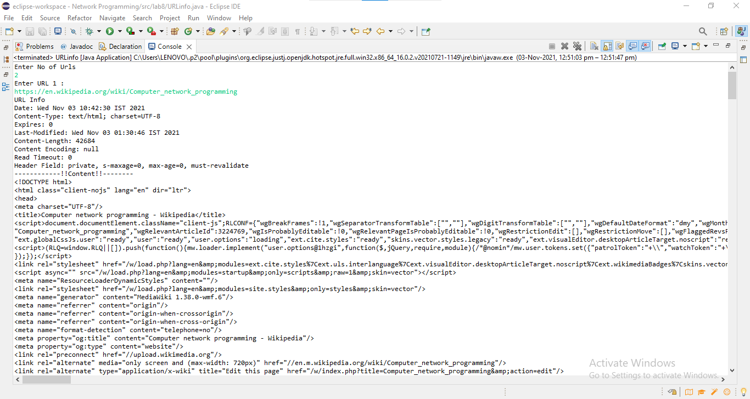

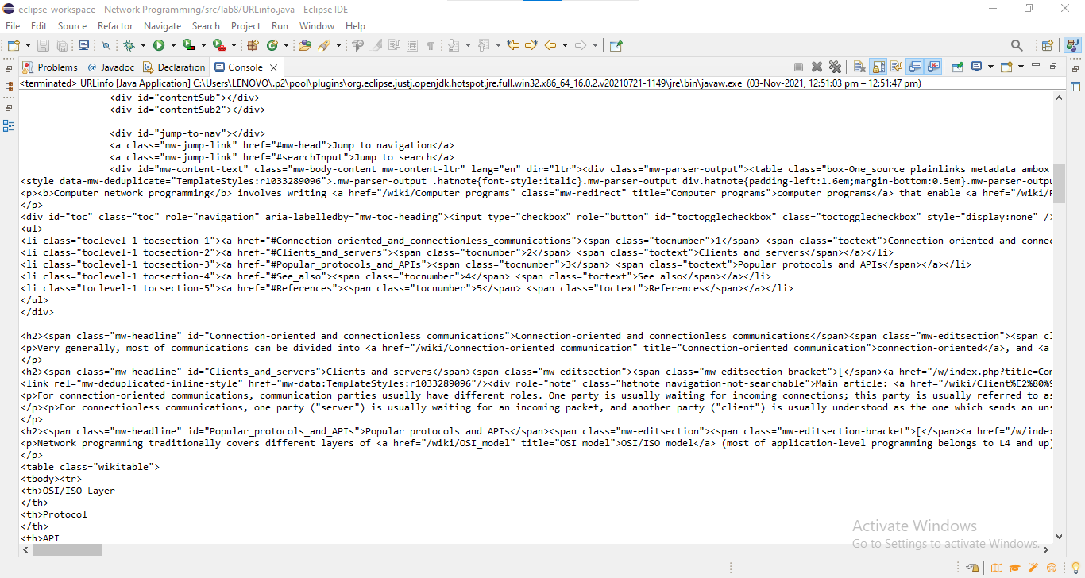

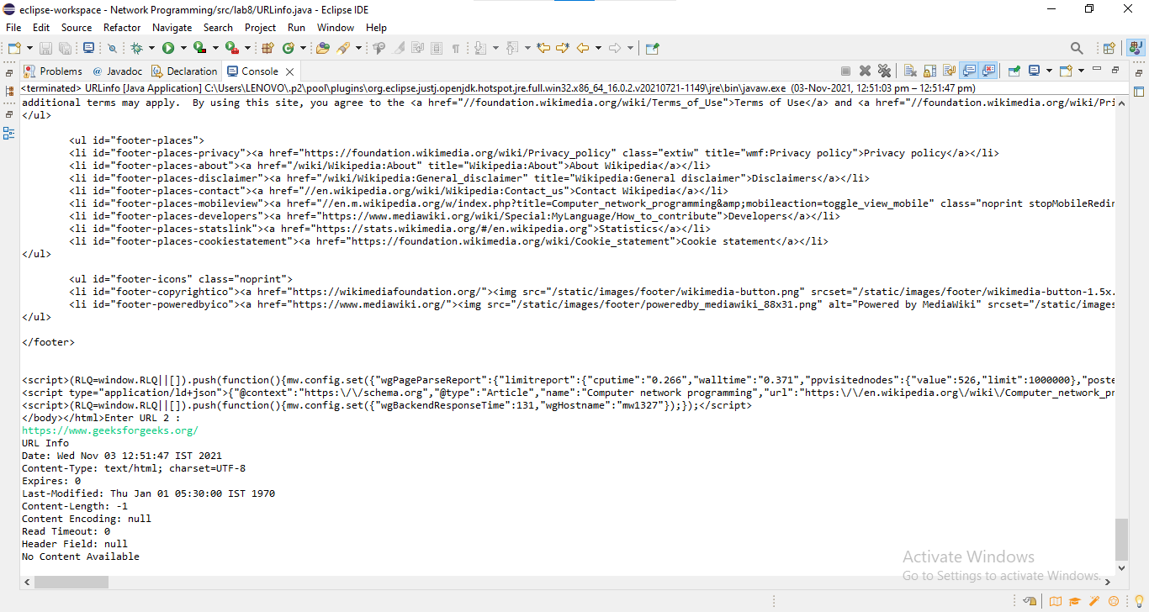

**CODE 3**

**URLConn.java**

**package** lab8;

**import** java.io.*;

**import** java.net.*;

**import** java.util.Scanner;

**public** **class** URLConn {

**public** **static** **void** main(String[] args) {

// **TODO** Auto-generated method stub

System.***out***.println("Enter No of Urls");

Scanner sin=**new** Scanner(System.***in***);

**int** n=sin.nextInt();

**try**{

**for**(**int** j=0;j<n;j++)

{

System.***out***.println("Enter URL "+(j+1)+" : ");

String u =sin.next();

URL url=**new** URL(u);

URLConnection urlcon=url.openConnection();

InputStream stream=urlcon.getInputStream();

System.***out***.println("Content Encoding: "+urlcon.getContentEncoding());

**int** i;

**while**((i=stream.read())!=-1)

{

System.***out***.print((**char**)i);

}

}

}

**catch**(IOException e)

{

System.***out***.println(e);

}

sin.close();

}

}

**Output:**

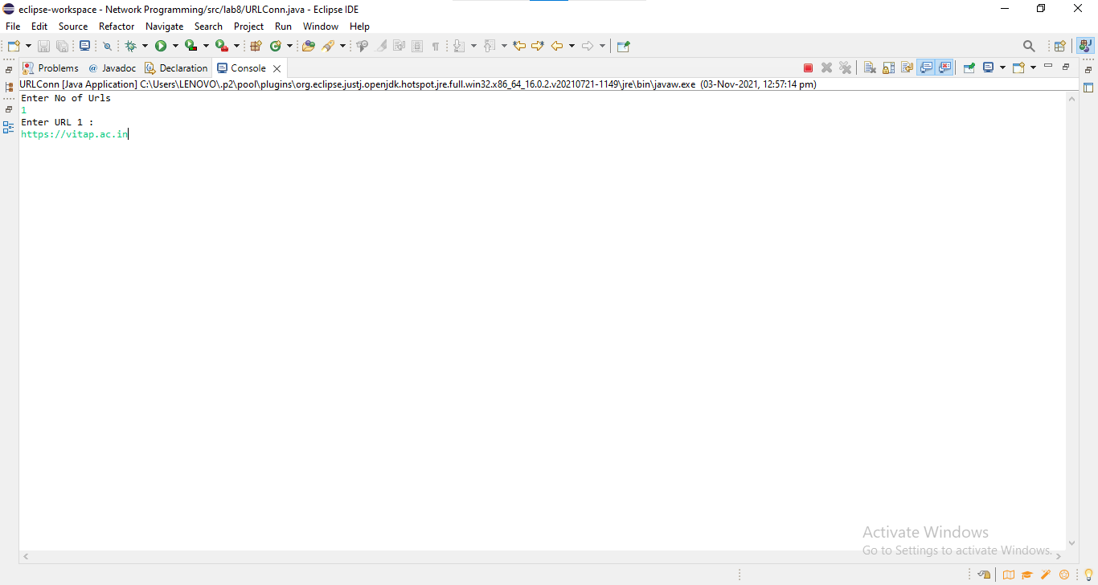

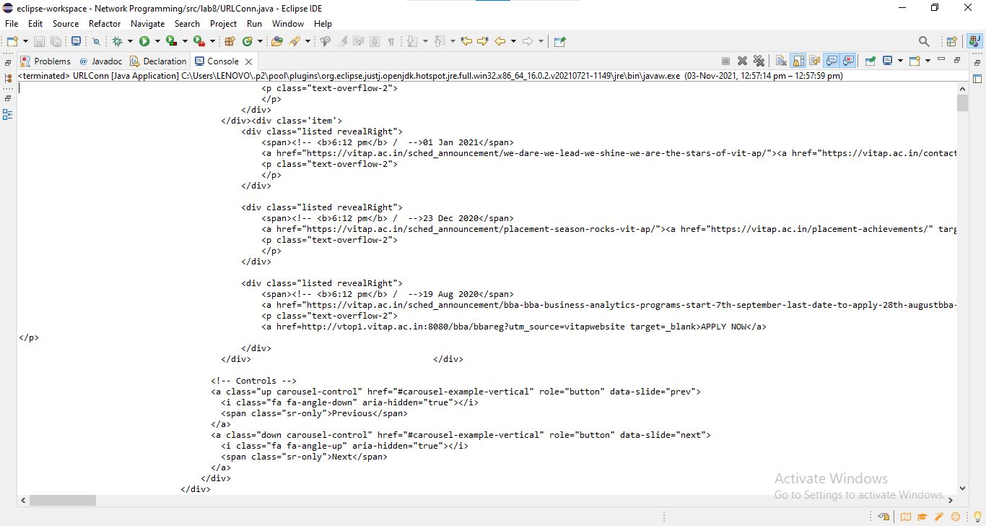

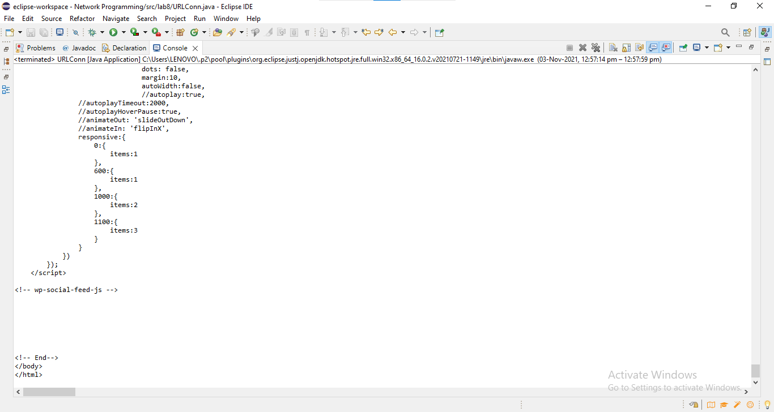

**CODE 4**

**URLReadFile.java**

**package** lab8;

**import** java.io.*;

**import** java.net.*;

**public** **class** URLReadfile {

**public** **static** **void** main(String[] args) **throws** IOException{

// **TODO** Auto-generated method stub

**try**

{

URL url = **new** URL("https://geeksforgeeks.org");

BufferedReader buff = **new** BufferedReader(**new** InputStreamReader(url.openStream()));

String str;

**while**((str = buff.readLine()) != **null**)

{

System.***out***.println("\n");

System.***out***.println(str);

}

buff.close();

}

**catch**(IOException e)

{

System.***err***.println(e);

}

}

}

**Output:**

